Project Design Phase-II
Technology Stack (Architecture & Stack)
Date | 29 September 2026
Team ID | SWTID-2026-7108
Project Name | Ai-WeatherWise API

Technical Architecture
The diagram below shows how the client, API gateway, controllers, services, database and external AI and weather services fit together.
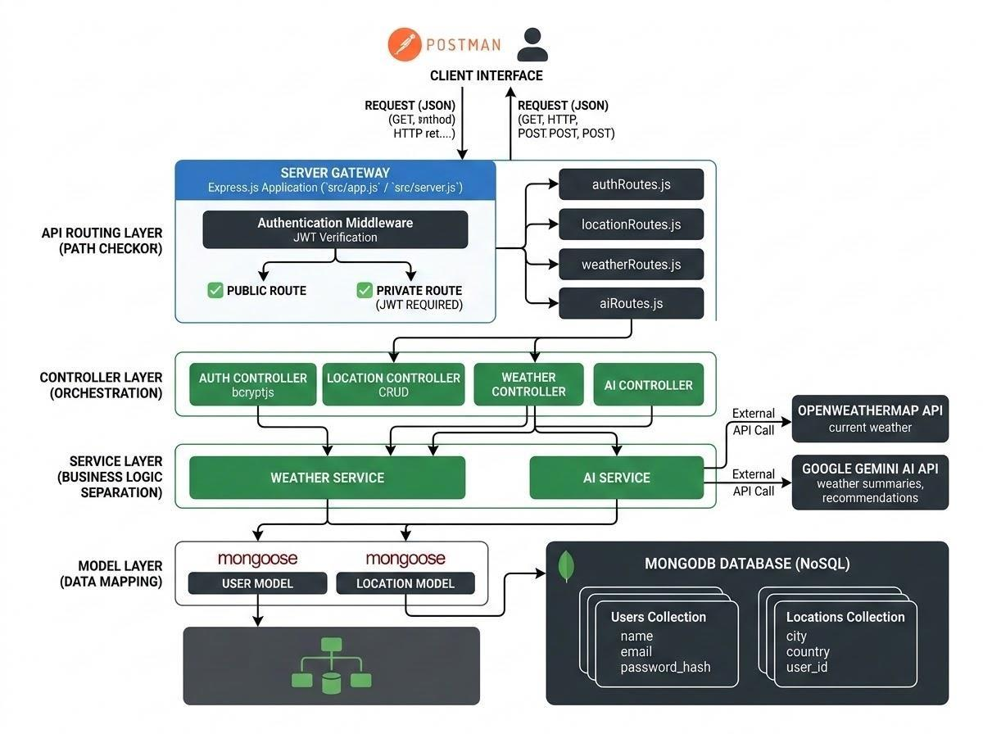
Figure 3: Technical architecture of AI WeatherWise API

Table 1: Components & Technologies
S.No | Component | Description | Technology
1 | Client Interface | API client used to send requests and view JSON responses | Postman / Thunder Client
2 | Application Logic-1 | Server gateway, routing and request parsing | Node.js, Express.js
3 | Application Logic-2 | Authentication and password security | JWT, bcryptjs
4 | Application Logic-3 | Weather retrieval from external service | OpenWeatherMap API
5 | AI Service | Weather summaries and recommendations | Google Gemini AI
6 | Database | Users and favourite locations | MongoDB
7 | Data Modelling | Schemas, validation and indexes | Mongoose ODM
8 | Infrastructure | Local development and execution | Local machine, VS Code, Nodemon

Table 2: Application Characteristics
S.No | Characteristic | Description | Technology
1 | Open-Source Frameworks | Backend and utility frameworks | Express.js, Mongoose, cors, dotenv
2 | Security Implementations | Hashing, tokens and sanitisation | bcryptjs, JSON Web Token, request sanitisation
3 | Scalable Architecture | Layered MVC design with separate services | Routes, controllers, services, models
4 | Availability | Fallback weather mode and centralised error handler | Express middleware
5 | Performance | Lightweight JSON responses and indexed queries | MongoDB unique index on user, city, country

